Torfaen Education Early Years ALN Provision Map
0-5 years

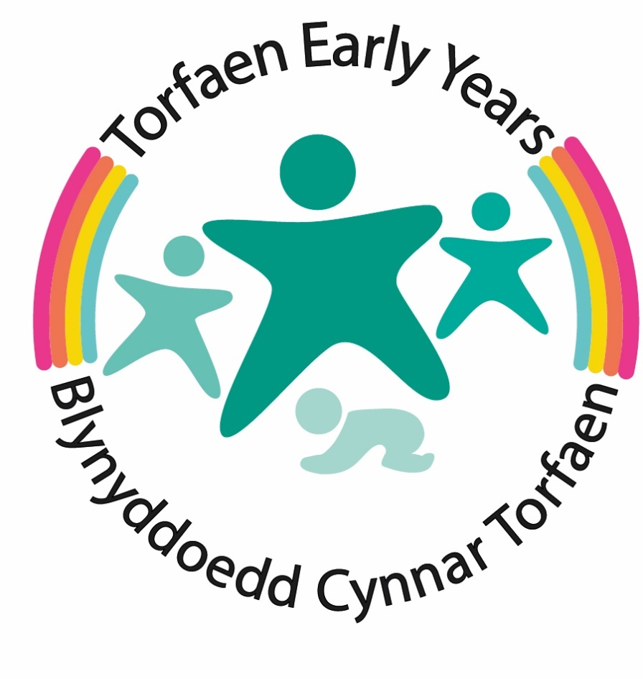

Contents
1.Overview 3
2.The Additional Learning Needs and Education Tribunal Act 2018 (ALNET) 4
3 Graduated Response 7
3.1 Monitoring learning 8
3.2 Levels of Support 9
4 Universal Offer 10
4.1Transition – good practice 10
4.2 Person centred Practice (PCP) 11
4.2.2What is a One Page Profile? 12
4.2.3What are Person-Centred-Practice Meetings? 13
4.3 Early Years Emerging Needs, Universal offer: Intervention and support 13
4.4 Universal Torfaen group support and advice/guidance 14
4.5 Useful links – Universal 17
5 Targeted provision 18
6 Specific Support 21
6.1 Local Authority Decision Making 22
6.4 ALN Assessment Process for an IDP (12 weeks) 24
7.Education, Early Years and ALN Team Key Contacts and Services 26
8. Useful links and Information 33
9. Glossary of Terms 34
Appendix 1 – Graduated Response Overview 39

1.Overview
Torfaen Local Authority (LA) aim to create inclusive cultures and communities in our early years settings and schools to maximise the educational opportunities for all Torfaen pupils. We want all children, parents, and staff to feel equally valued. Breaking down barriers to children’s learning to encourage their full participation by offering all children an education, which is designed to enable them to be included, and participate fully, in the society to which they contribute and from which they benefit.
The Local Authority’s Early Years and Inclusion and Pupil Support teams provide a wide range of services to early years settings and schools. These aim to promote inclusion and supports school with advice, guidance, and support to help them plan and meet the needs of pupils who are vulnerable and those who have or may have Additional Learning Needs (ALN) as part of our graduated response.
The majority of pupils will have their needs identified, met and monitored within their early years setting, maintained mainstream school or college. All children and young people learn in different ways and at different rates. In every education setting there will be some learners who progress at a slower rate than others. These learners will benefit from differentiated good quality teaching and learning and universal support. Some pupils will be identified as having an Additional Learning Needs and require more targeted interventions and a small number of pupils will require more specific Additional Learning Provision provided by their setting.
This document sets out Torfaen’s service offer and processes for meeting the requirements of the ALN and Educational Tribunal Act 2018 and sets out how to access the Local Authority services and provisions for early years learners.
This document is for the following groups of Early years professionals:

      - Early Years Settings.
      - Child Minders
      - ALNCos and ALN Leads in Early Years settings.
      - Teachers and support staff
      - LA Inclusion Staff

2.The Additional Learning Needs and Education Tribunal Act 2018 (ALNET)

The Additional Learning Needs and Education Tribunal Act 2018 (ALNET) will be implemented in Wales from September 2021.
The principles underpinning the ALN system are:
- A rights-based approach
- Early identification, intervention and prevention
- Collaboration and integration
- Inclusive education
- A bilingual system
The vision of the Welsh Government is to deliver a fully inclusive education system for the learners of Wales. Planning should be flexible and responsive, and professionals should be skilled and confident in identifying needs. The learner should be at the centre of everything we do, and they and their parents or carers seen as equal partners in their learning; this is known as Person Centred Practice (PCP).
There are 11 key changes from the previous legislation:
- ALN to replace term SEN
- Act to cover 0 - 25 year olds
- A unified statutory plan called the Individual Development Plan (IDP)
- Increased participation of children and young people (PCP)
- High aspirations and improved outcomes
- A simpler less adversarial system
- Increased collaboration
- Avoiding disagreements and earlier disagreement resolution
- Clear and consistent rights of appeal
- The ALN Code
- A bilingual system

2.1 Responsibilities of the Local Authority

The Code sets out the role and responsibilities of the Local Authority in detail and those most relevant to Early Years learners are as follows:

10.1. Every local authority must designate an officer to have responsibility for coordinating the local authority’s functions under the Act in relation to children under compulsory school age who are not attending maintained schools. The designated officer is to be known as the ‘Early Years Additional Learning Needs Lead Officer’ (‘the Early Years ALNLO’).

6.1. Local authorities must make arrangements to provide people with information and advice about ALN and the ALN system. In doing so, they must have regard to the principle that information and advice provided under the arrangements must be provided in an impartial manner.

11.5. Where it is brought to its attention, or otherwise appears to a local authority, that a child for whom it is responsible may have ALN, the local authority must decide whether the child has ALN unless one of the following circumstances applies:
- an IDP is already being maintained for the child;
- the local authority has previously decided the issue and is satisfied that the child’s needs have not changed materially since that decision and there is no new information which materially affects that decision.

11.21. If the local authority decides that the child has ALN, it must prepare an IDP for the child.

  - Local authorities are directly responsible for meeting the needs of children and young people with the most complex or severe needs and those who do not attend a maintained school or FEI (including those below school age).

1.85. Local authority funded non-maintained providers of nursery education have a role in supporting local authorities to identify ALN and in helping local authorities to fulfil their statutory obligations.
2.2 Definition of Additional Learning Needs (ALN)

The Additional Learning Needs Code for Wales 2021 provides a clear definition of what constitutes an additional learning need:

Definition of additional learning needs:
(1) A person has additional learning needs if he or she has a learning difficulty or disability (whether the learning difficulty or disability arises from a medical condition or otherwise) which calls for additional learning provision.
(2) A child of compulsory school age or person over that age has a learning difficulty or disability if he or she —
(a) has a significantly greater difficulty in learning than the majority of others of the same age, or
(b) has a disability for the purposes of the Equality Act 2010 which prevents or hinders him or her from making use of facilities for education or training of a kind generally provided for others of the same age in mainstream maintained schools or mainstream institutions in the further education sector.
(3) A child under compulsory school age has a learning difficulty or disability if he or she is, or would be if no additional learning provision were made, likely to be within subsection (2) when of compulsory school age.
(4) A person does not have a learning difficulty or disability solely because the language (or form of language) in which he or she is or will be taught is different from a language (or form of language) which is or has been used at home.

Just because a child or young person has a disability or a medical condition, this doesn’t automatically mean that they have ALN. It is only if their disability or medical condition prevents them from accessing mainstream provision and they need ALP that they are considered to have ALN.

2.18. Those children and young people who are considered ‘more able and talented’ do not have a difficulty in learning on the basis of their enhanced ability or talent. These children and young people may require enhanced opportunities and challenge in order to reach their full potential, but this ought to be provided as part of differentiated teaching.
2.2 Additional Learning Provision (ALP)

Definition of additional learning provision:
(1) “Additional learning provision” for a person aged three or over means educational or training provision that is additional to, or different from, that made generally for others of the same age in—
(a) mainstream maintained schools in Wales,
(b) mainstream institutions in the further education sector in Wales, or
(c) places in Wales at which nursery education is provided.
(2) “Additional learning provision” for a child aged under three means educational provision of any kind.
(3) In subsection (1), “nursery education” means education suitable for a child who has attained the age of three but is under compulsory school age.

2.15. ALP for those aged under three can take many forms; for instance, group work or individual support - where it is educational provision of any kind. This might include, for example, educational provision in Flying Start or specialist health, physical, communication or sensory support. This can take place in an education setting or elsewhere.

2.42. In the case of young children, learning ought to provide the opportunity to develop their knowledge, skills and understanding of the world through exploratory play and experiences. Children with ALN might require ALP in the form of exploratory play, or other ALP to enable them to access appropriate play opportunities/activities.

3 Graduated Response

Early intervention is key and we apply a graduated response. Support and strategies are put in place when children are exhibiting emerging needs. Many learners have developmental needs that with regular attendance at early years settings and access to good quality universal provision make appropriate progress and do not have longer term needs. This may prevent learners from developing longer term needs and requiring more targeted or specific provisions.

The Local Authority’s Early Years and Inclusion and services provide a wide range of services which aim to promote inclusion and support early years settings with advice, guidance and support to help them plan and meet the needs of learners who have emerging needs and those who have or may have Additional Learning Needs as part of our graduated response.
The majority of learners will have their needs identified, met, and monitored by their early years setting. All children and young people learn in different ways and at different rates. In every setting there will be some learners who progress at a slower rate than others. These learners will benefit from differentiated good quality provision, teaching, and learning and universal services.
Torfaen promotes the Personal Centred Planning approach for all children who have emerging or identified needs and have a My PCP document alongside a One Page Profile and Action Plan for parents/carers and professional to follow.
Some learners will have an identified need and require more targeted interventions provided by their setting or from the Local Authority services following a request for involvement for advice, guidance, or intervention. A small number of learners will have severe and complex Additional Learning Needs which require specific and individualised additional learning provision to be put in place for them through an Individual Development Plan (IDP).

3.1 Monitoring learning

Observation and assessment are important tools in monitoring the progress of individual learners and determining what stage they are at on the graduated response. Early years settings can use the following model to develop a growing understanding of the learner’s needs and what supports the learner to remove barriers to learning and make good progress.

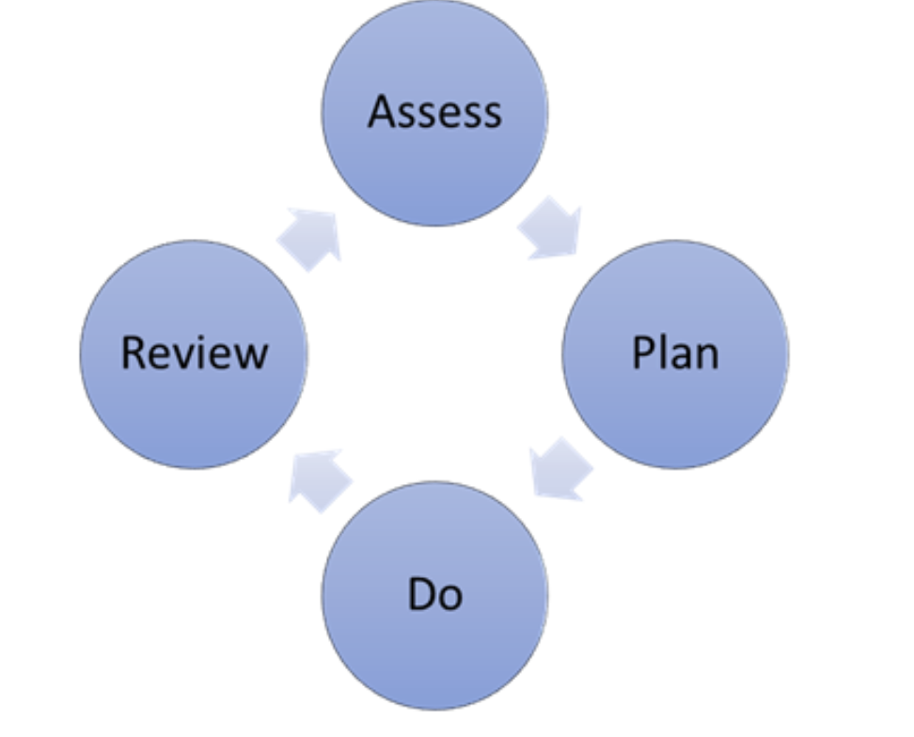

Monitoring process and template | -

Early years settings will monitor the progress of individual learners regularly to determine the support and provision they require. They will gather a range of information to support them to plan the next steps for the learner.

Sources of evidence could include:

- standardised screening or assessment tools and frameworks.
- observational data;
- the quality of their work.
- developmental checklists;
- scaling questionnaires.
- assessments from other agencies, such as health bodies, and
- behaviour and social emotional questionnaires and standardised test

If a learner continues to experience difficulties accessing learning and making progress, despite high quality universal and targeted provision, they may be considered to have severe and complex needs. As outlined in the normal curve of distribution, this is likely to be less than 2% of the national population.

3.2 Levels of Support

Provision to meet the needs of pupils with emerging needs or for those who have or may have Additional Learning Needs (ALN) will fall into one of three tiers.; universal support, targeted support or specific support. As the triangle suggests, the majority of children will have their needs met by accessing the universal offer, some will be receiving targeted support and a relatively small number of children will require specific support (Additional Learning Provision).
For each of the three tiers of provision (Universal Provision, Targeted Provision and Specific Provision) the Early years setting will plan, monitor and review their decisions and actions to meeting the child’s needs. This process builds into a growing understanding of the child’s needs and of what supports the learner requires to remove barriers to learning and make good progress.
It must be noted that there will be some children with profound and complex needs will be accessing the specific and individualised support stage immediately.

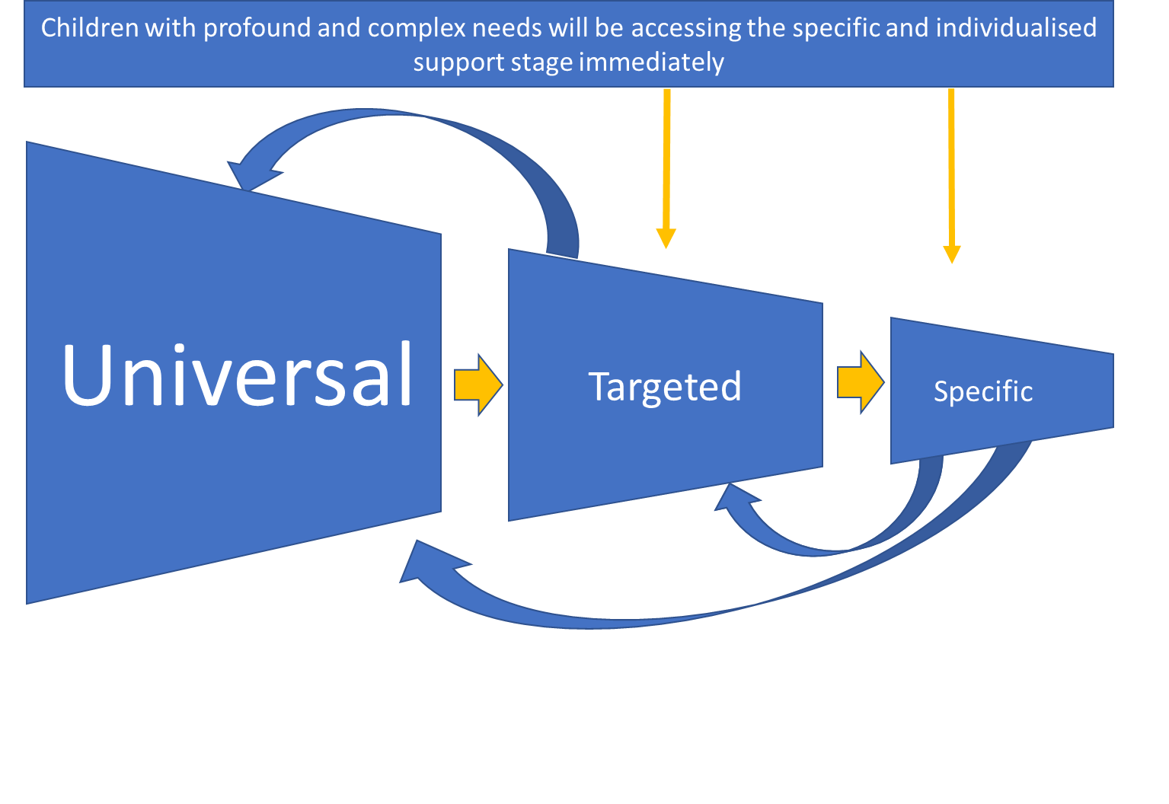

4 Universal Offer

Meeting the needs of learners with emerging needs or those with ALN is part of a whole early years setting approach. Learning environments are tailored to meet the needs of all children and young people, so they can make progress in learning and wellbeing.

The key to meeting the needs of all learners lies in the staff’s knowledge, skills, and abilities. The staff’s capacity to then match this knowledge with identifying ways of providing appropriate access to the curriculum for every child and young person is also critical.
Reasonable adjustments can be required to overcome barriers to learning, these can be associated with seating position, timings, resources etc. For individuals who require reasonable adjustments following the graduated response within the setting, a My PCP profile may be developed to share this information with all stakeholders.

4.1Transition – good practice

Smooth transitions within the Early Years depend on a commitment from all professionals involved to develop positive communication links. In order to promote continuity for all children experiencing transitions between settings, it is important that there is a shared approach between all those professionals involved.

For families with children with additional needs, change may be particularly stressful and the transitions process should be given particular consideration. Families may be concerned about how their child will settle and whether the nature of their child’s needs will be understood. They may require more visits and opportunities to visit the setting and get to know staff than other children. It may be helpful to provide children (especially useful for children with speech, language and communication needs and children on the autism spectrum) with photos of the setting, including pictures of staff, the toilets and the front entrance.

With parental consent, the childcare setting staff should notify the Foundation Phase school/setting about the additional needs of children as early as possible so that they can plan effectively to meet those needs. The Early Years Educational Psychologist should be notified as early as possible of the FPN to ensure the needs of the child are met when transitioning. Any documentation should be passed on as early as possible, preferably with a face-to-face meeting, which includes parents. A One Page Profile or an ‘All About Me’ type information can be written with the child/ parents and professionals which can be sent to the receiving Foundation Phase setting.

To achieve a smooth transition, practitioners should ensure that the receiving setting/school is aware of the child’s progress and his/her future developmental needs. This should include information about the particular strategies that have worked in the childcare setting and the equipment and activities used. Information should be provided to the Foundation Phase setting well in advance if adaptations or specialist equipment will be needed.

Ideally regular meetings should be held between the Advisory teacher, Additional learning Needs Co-ordinator (ALNCO) and teacher (or Foundation Phase setting leader). Ideally, other relevant professionals involved with the child’s care should be invited to discuss the child’s requirements and support needs. This should be in the form of a PCP meeting, as directed in the new ALNET Act.

Torfaen Transition Policy and Procedure

4.2 Person centred Practice (PCP)
PCP is a collection of tools and approaches, based upon a set of shared values, which can be employed to effectively plan with a child/young person, rather than for them. PCP tools assist the child/young person, to consider what is important to them at the present time, encourage them to think about what would constitute a successful future, and to actively identify the support they require to achieve this future. A person-centred approach helps to develop the child/young person’s circle of support by involving all the people who are important in that child/young person's life, including parents/carers, and professionals working with them.
There is no single method of working; it is more a collective of approaches and styles, making it more difficult to define. Adopting a person-centred approach is a way of giving the child or young person at the centre of a plan a voice and a say in what happens to them. Individual professionals have expertise and knowledge and know what is ‘important for’ a child but a successful plan needs to be balanced to reflect what is ‘important to’ the child also.
There are five key principles of Person-Centred Practice:
- The person is at the centre
- Family members and friends are partners in planning
- The plan reflects what is important to the person now (and for the future) their capacities and what support they require
- The plan helps build the person’s place in the community and helps the community to welcome them. It is not just about services, and reflects what is possible, not just what is available
- The plan results in on-going listening, learning, and further action.

PCP Guidance for settings

PCP Guidance for professionals

4.2.2 What is a One Page Profile?

A One Page Profile captures all the important information about a person on a single sheet of paper under three simple headings: what is great about me, what and who is important to me and what do I need a little help with and how can you help me.

One Page Profile document

How can they help us to support people better?
One Page Profiles are easy to develop and help us to support people better by:
- Helping us build better relationships by truly understanding what really matters to the person in their life and the way they are supported to live it
- Providing a record that can move with the person as they transition from service to service or use multiple services
- Being regularly updated to reflect people’s changing circumstances and aspirations
- When staff have One Page Profiles, the people being supported feel like they get to know the person, rather than just the job title
- When used at work, they can contribute to more person-centred teams, where individual strengths are recognised and different ways of working are taken into account

4.2.3 What are Person-Centred-Practice Meetings?

Person-Centred-Practice meeting uses person-centred thinking tools to explore what is happening from the person’s perspective and from other people’s perspectives. This results in outcomes and actions for person-centred change, and ensures that a range of people are involved when the review is happening, and that their views and ideas are recorded in a structured, step-by-step way by :
- Making sure that we’re truly taking into account the experiences of the person, their family and those supporting them when reviewing how well things are going
- Creating an environment where people are made to feel comfortable in expressing themselves honestly
- Developing actions that are based on experiences and learning, leading to an environment where we’re constantly improving our support
Learning environments are tailored to meet the needs of all children and young people, so they are able to make progress in learning and wellbeing.

My PCP template
My PCP Review template

4.3 Early Years Emerging Needs, Universal offer: Intervention and support

Within Early Years we look at how we can support families with an emerging need, where resources are available. We aim to provide an integrated approach to Family Support services utilising the existing structures and systems delivered by all Early Years Services. Torfaen Early Intervention Panel has been established to provide a single point of access, regardless of funding streams, to provide early intervention and additional support to vulnerable children and families identified for those with emerging needs under pour Universal services offer.

4.4 Universal Torfaen group support and advice/guidance

In addition to each setting universal services and provision the following groups and services are available to access.
Drop-in Groups | Drop in groups are advertised via Early Years teams and social media. No referral is required, families do need to book a place:  https://www.facebook.com/TorfaenEarlyYears  Muddy Marvels  Outdoor drop in session that promotes playing within nature.  Each week we have a nature/seasonal based topic and use the natural materials around us to explore and learn.  Little Explorers  An outdoor drop in session that incorporates language and play, playing within nature where families can have fun in a relaxed environment. The session will incorporate well-being and activities that will enhance early years education.  Baby Allsorts  Outdoor group for babies 3-12 months promotes:  - positive adult-child interaction at the earliest possible stage  - early attachment and communication skills  - a stimulation/communication rich environment through interactive, fun activities  Family Fun Time  A drop in session that embeds the language and play programme. We share ideas and tips to help your child with play and talking skills where families can have fun in a relaxed environment. The session will incorporate well-being and activities that will enhance early years education.
Parenting Programmes | Weekly group or 1:1 support for families on a more formal basis. Access usually by professional referral using the following form but families can self refer:  Welcome to the World: 8 week programme  Expectant mums are invited at approximately 22 weeks pregnant. This is group is supported by a Midwife. Focussing on Emotional Health. The importance of Attunement, Attachment and Empathy, the physical and practical needs and anxieties of parents to be.  Playful Parenting:  To improve family relationships and children’s social, emotional and cognitive development, children 1-2 years.  Baby Elklan:  Interactive 8 week course for parents/carers and their babies aged from 3-12 months.  Let’s talk with your baby aims to:  Promote positive adult-child interaction at the earliest possible stage. Promote early attachment and communication skills. Provide a stimulation/communication rich environment through interactive, fun activities  Family Links: The programme is a structured, interactive parenting programme promoting emotional health and mental wellbeing, relationship skills and positive behaviour management strategies for parents, carers and their children. The programme offers a holistic approach and is suitable for families with children up to 11 years  Circle of Security: eight week programme: relationship based parenting programme which helps parents to understand their child’s emotional needs and strengthen their relationship with their child  Incredible Years  Baby Incredible Years - formal group 9 sessions, appropriate for parents with babies 0-5months  Toddler Incredible Years - formal 12 week programme, appropriate for families with children 12-24 months.
Educational Psychology | General advice and guidance (not pupil specific) /Training//Drop-in sessions/ signposting/Resources
ASD Officer support | General advice and guidance on ASD strategies Training//Drop-in sessions/Person Centred Planning/signposting/Resources  Drop-in sessions for pupils undergoing or about to undergo the ND assessment.
COMIT

4.5 Useful links – Universal

Early Language and Communication

- Aneurin Bevan University Health Board (ABUHB) Speech and Language Therapy: https://abuhb.nhs.wales/files/speech-and-language-therapy/
  - Helping your child learn about language
  - Helping young children who stammer
  - Helping your child with unclear speech
  - Speech Sounds - Guide for Parents
  - ‘Talk With Me’ Poster (English)
  - ‘Talk With Me’ Booklet (English)
  - Tips for Talking - children aged 3y -3y11m years
- BBC Tiny Happy People https://www.bbc.co.uk/tiny-happy-people
- Hungry Little Minds (activities for 0-5) https://hungrylittleminds.campaign.gov.uk/
- I Can CPD Short Course https://ican.org.uk/i-cans-talking-point/cpd-short-course/
- I Can Universally Speaking birth – 5 tct_univspeak_0-5_update.pdf (ican.org.uk)
- Welsh Government Talk with me https://gov.wales/talk-with-me

Parenting. Give it Time. Guidance and Support from experts in Wales
https://gov.wales/parenting-give-it-time

Torfaen Early Years ALN module Training Delivery – to book onto training contact Childcaresupport@torfaen.gov.uk
Module 1 - ALN ACT Awareness
Module 2 - Code of Practice/Role of ALNCO (from spring term 2022)
Module 3 part 1 - Introduction to Person Centred Practice
Module 3 part 2 – PCP meetings and Reviews
Module 4 – Smart Targets
Module 5 – Creating an Inclusive Setting
Module 6 – Working with Professionals
Module 7 – Working with Parents

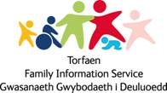
For more information on services available please contact the Family Information Service on our freephone 0800 0196330, visit the Torfaen Family Information Service website or e-mail fis@torfaen.gov.uk

5 Targeted provision

Where a learner has been accessing universal provisions but following monitoring and review using the person-centred planning approach the learner continues not to be making appropriate progress the setting may consider putting in place targeted interventions. The setting will have a range of targeted provision in place which can be short or long term to meet an identified barrier to learning. This can also include support from staff with specific training, accessed through resources or request for external interventions. A One Page Profile is developed with all stakeholders which provides key information on the pupil to all working with the individual. This will be reviewed at least annually. Within the targeted intervention, there will be set targets of focus, through which school staff will continue to track and monitor progress.

Targeted Interventions and support provided by Local Authority services can be requested from the Early Years Intervention Panel. The panel will review the information received from the setting and discuss what targeted interventions/support may be required for the learner. Any interventions/support awarded will be monitored and reviewed by the panel.

The Intervention panel is a multidisciplinary team of LA staff which includes Early Years officers, Educational Psychology, ALN and ASD officers. It is a single point of contact for settings to request access to services where they wish to receive advice or LA targeted interventions to support the learner. The panel discuss the information provided and decide on the appropriate interventions/support required. Interventions and pupil progress are monitored.

  - Early Support Panel - Single point of access
Early Years Request Form

The request for involvement form is completed by the setting and are returned to the Early Years ABS hub (EY-InterventionALNPanel@torfaen.gov.uk).
The request is checked to ensure that all information that is required has been submitted. Criteria for each grant is met. Settings will be contacted to provide missing/additional information where necessary prior to discussion at the panel.
Onward signposting or requests for other agencies involvement are made where appropriate

e.g. Tafarn Newydd/
Panel meetings are held every two weeks and each request is discussed and the intervention of request for support decided upon.

After the panel: Childcare settings and parents/carers are notified by email. This is followed up in writing to the childcare setting and parent/carers and is completed within 5 working days of the panel date.

Monitoring – following the intervention of advice the panel will monitor the support/intervention provided and request updates on a termly basis.

5.2 Identified Need, Targeted Torfaen group support - Early Intervention

The following targeted interventions and support can be accessed via the Early Intervention panel single point of access request of involvement.

Wriggly Woos | A small group for children aged 17 months – 4 years with or waiting for a diagnosis of Autistic Spectrum Disorder.  Access following professional referral normally following 15 month Health Visitor review of 18 month WellComm assessment.  Access through Early Support Panel
Playing Together Group | A small group for parents/ carers and children 15 months – 35 months with global delay.  The group focuses on developing play skills. Parents are provided with a weekly ‘Talk with Me’ strategy and children have Individual Play Plan targets.  Access following professional referral normally following 15 month Health Visitor review of 18 month WellComm assessment.  Access through Early Support Panel
Talking Together Group | A small group for parents/ carers and children 18 months - 35 months with delayed talking skills.  Parents are provided with a weekly ‘Talk with Me’ strategy and children have Individual Play Plan targets.  Access following professional referral normally following 15 month Health Visitor review of 18 month WellComm assessment.  Access through Early Support Panel
Short term home support | 1:1 session for parents/carers and children aged 0-5 years who need support to develop their child’s play and talking skills before accessing group.
Early Year’s Childcare Support Officers | Children requiring support are identified during transition meetings.  The Early Years Support Officer / Childcare Offer Support Officer work with the family and Childcare Setting to co-ordinate any additional support, resources and/or training to support attendance at Childcare.  Access through Early Support Panel
Educational Psychology | Access through Early Support Panel  Advice and Guidance to settings to support and plan for individual learners.  Educational Psychology consultations and observations /Individual learner planning/ Multiagency meetings / Bespoke training
ASD officer | Advice and Guidance to settings to support and plan for learners.  Group or individual consultations and observations /Individual learner planning/ Multiagency meetings / Bespoke training

5.3 Useful links
ASD | https://gov.wales/sites/default/files/publications/2019-01/ways-of-supporting-learners-with-autistic-spectrum-disorder-asd.pdf
Transition tool

6 Specific Support

A small number of learners will have severe and complex needs that despite universal and targeted provision being made for them they continue not to make appropriate progress and require individual or bespoke planning and support. A multi-disciplinary approach is required to maximise progress and develop and review additional learning provision. This is where provision needs to be different from that which is provided by universal and targeted interventions and is specific and individual for the pupil.
These learners will require an assessment to ascertain if they require an Individual Development Plan. A request may be made to the Local Authorities ALN team to undertake an assessment of Additional learning needs to determine if an Individual Development plan is required.

Identifying if a learner has Additional Learning Needs (ALN) which will require a Local Authority Individual Development Plan (IDP) will be based on a wide range of evidence gathered over time. Most children will have their needs met by their childcare setting or non-maintained nursery education provider through universal and targeted interventions. Referrals to outside agencies may be required for some children to provide additional advice to support the setting to plan for the learner.

The ALN and Education Tribunal Act 2018 states that :
The possibility that a child has ALN might be brought to the attention of a local authority in a number of ways. It may start with a referral from one of a wide range of different agencies and professionals. For example, a provider of childcare or non-maintained nursery education might inform the local authority where it suspects a child has ALN. Alternatively, a health body might have formed the opinion that the child has or may have ALN, and brought this to the attention of the local authority in compliance with its duty in section 64 of the Act. Concerns might also be expressed by the child’s parents. These concerns might be raised through a non-maintained education setting (if the child attends one) or directly with the local authority. Parents’ observations of their child are often crucial to early identification. Local authorities and non-maintained nursery providers should be open and responsive to such expressions of concern and take account of any information (chapter 11.6)

All requests for an ALN assessment should be made too the ALN team at AdditionalLearningNeeds@torfaen.gov.uk

6.1 Local Authority Decision Making

The local authority has a duty to decide whether a child under compulsory school age who is not attending a maintained school in Wales has ALN.

Where it is brought to its attention that a child may have ALN by parents/carers, professionals or any other party, the Local Authority must determine if a child has ALN by taking expert advice and gathering information from those involved with the child’s healthcare and learning.

The early years settings system for observing and assessing the progress of individual children will be key in providing information and evidence regarding areas where the child is not progressing satisfactorily.

A parent/person with parental responsibility or professional can bring to the attention of the Local Authority that they think the child may have ALN and ask for an assessment to determine if they have Additional Learning Needs (ALN) that requires Additional Learning Provision (ALP) to support them.

A request can be made by:

- The child’s parents/person who has parental responsibility directly to the local authority.
- A provider of childcare or non-maintained nursery education who informs the local authority ALN Team where it suspects a child has ALN.
- A health body where they have formed the opinion that the child has or may have ALN and brought this to the attention of the local authority in compliance with its duty in section 64 of the Act.

NB - Consent from the parent/person with parental responsibility is required to enable the ALN team to carry out an ALN assessment.

The assessment to decide if a learner has Additional Learning Needs that requires an IDP for learners attending childcare or non-maintained nursery education will be undertaken by the ALN team and follow the statutory processes set out in the ALN and Education Tribunal Act 2018 and ALN Code of Practice March 2021.

Children attending nursery education at a maintained school will have their needs assessed by the school.

6.2 Identification of ALN and ALP

Applying the definitions to children under compulsory school age is slightly different for establishing whether a child under compulsory school age has ALN

(a) Does the child have a learning difficulty or disability?

The first test is if the child has a learning difficulty or disability, that when they are of, compulsory school age, would have:

- a significantly greater difficulty in learning than the majority of others of the same age, or
- a disability (within the meaning of the Equality Act 2010) which prevents or hinders the child from making use of facilities for education or training of a kind generally provided for others of the same age in mainstream maintained schools.

(b) Does the learning difficulty or disability call for ALP?

The second test is whether the learning difficulty or disability calls for ALP.

- For children aged under three, ALP means educational provision of any kind that is assessed as required to enable the child to make progress. ALP for those aged under three can take many forms; for instance, group work or individual support - where it is educational provision of any kind. This might include, for example, educational provision in Flying Start or specialist health, physical, communication or sensory support. This can take place in an education setting or elsewhere

- For those aged 3 and over, ALP has the same meaning as for children of compulsory school age and young people regardless of the setting attended.

The Assessment process will take up to 12 weeks and through this process information will be gathered from all involved with the learner using a person-centred approach.
Where it is agreed that the learners requires an IDP the assessment will determine what specific Additional Learning provision /support/interventions the learner may require to support them to access learning in their setting. The IDP when finalised will be reviewed at least annually to monitor and review the learners progress.

6.3 Additional Learning Provision
Early years providers should take steps to secure the ALP required by a learner if identified via the process - they do not have to wait until the IDP is written to put it in place.
“Where a child receives nursery education funded by a local authority at a non-maintained provider, the provider should, where requested, help the local authority in the exercise of its ALN functions in relation to that child, including in instances where a child receives nursery education from both maintained and non-maintained providers.”

6.4 ALN Assessment Process for an IDP (12 weeks)
It is brought to the attention of the ALN Team that a child attending a childcare setting or non-maintained nursery may have ALN and a request for assessment is made from:

- A parent/person with parental responsibility
- Health professional
- Childcare or non-maintained nursery education setting

The request is sent to the Additional Learning Needs email address:.mailto:AdditionalLearningNeeds@torfaen.gov.uk
Early years setting, Health /Social Care professionals must obtain signed consent from the parents/person with PR prior to sending in the request.

Assessment Starts (Day 1)
LA note of date/ details of the request and record a summary of how the possibility that the learner has ALN has been brought to its attention or why it otherwise appears that the learner may have ALN from the information provided.
The assessment is started and letters confirming the assessment are sent to parents, learner and professionals involved.

Gathering Information
- The Designated ALN Officer liaises with EY Intervention Team and requests reports/information from other professionals to gather information.
- Letter sent to invite parents and professionals involved to a Person-Centred Planning meeting

Gathering Information

- The Designated ALN Officer liaises with EY Intervention Team and requests reports/information from other professionals to gather information.
- Letter sent to invite parents and professionals involved to a Person-Centred Planning meeting

Gathering Information

- The Designated ALN Officer liaises with EY Intervention Team and requests reports/information from other professionals to gather information.
- Letter sent to invite parents and professionals involved to a Person-Centred Planning meeting

Gathering Information

- The Designated ALN Officer liaises with EY Intervention Team and requests reports/information from other professionals to gather information.
- Letter sent to invite parents and professionals involved to a Person-Centred Planning meeting

Gathering Information

- The Designated ALN Officer liaises with EY Intervention Team and requests reports/information from other professionals to gather information.
- Letter sent to invite parents and professionals involved to a Person-Centred Planning meeting

Gathering Information

- The Designated ALN Officer liaises with EY Intervention Team and requests reports/information from other professionals to gather information.
- Letter sent to invite parents and professionals involved to a Person-Centred Planning meeting

PCP meeting
- PCP meeting takes place to share and gather information from all involved with child.
- PCP information is submitted to LA.

PCP meeting

- PCP meeting takes place to share and gather information from all involved with child.
- PCP information is submitted to LA.

ALN Panel
- ALN panel review the information collected as part of the assessment process and decide if the child requires an IDP based on information presented.

- A letter confirming outcome of panel is sent to parents/carers the learner and professionals.

ALP – check code/clarify gap provision?
Early years providers should take steps to secure the ALP if identified via the process - they do not have to wait until the IDP is written
“Where a child receives nursery education funded by a local authority at a non-maintained provider, the provider should, where requested, help the local authority in the exercise of its ALN functions in relation to that child, including in instances where a child receives nursery education from both maintained and non-maintained providers.”

Decision - Learner has ALN but does not require ALP to meet need and will not have an IDP

Decision - Learner does not have ALN

Decision - Learner has ALN that requires ALP so an IDP will be prepared.

Parents/professionals are informed of decision along with any panel recommendations for the learner.
Parents/professionals are informed of decision along with any panel recommendations for the learner.

Designated ALN Officer prepares proposed IDP using information collated from the PCP meeting and received information/reports provided to the LA from agencies involved.

EY Setting continues to meet need via graduated response and universal/targeted provision.

EY Setting continues to meet need via graduated response and universal/targeted provision.

Proposed IDP
Proposed IDP sent to parents for comment

Following discussions/meeting with parents the IDP content is agreed

IDP finalised (12 weeks)
Final IDP sent to parents and professionals.

IDP review
The IDP must be reviewed within 12 months of it being finalised. LA to contact all parties to set up review.

Education, Early Years and ALN Team Key Contacts and Services

Early Years ALN Lead Officer  Responsible for the ALN requirements for 0-5 years under the direction of the Head of Learner Support and direction and support from the core ALN Inclusion team and Early Years partners | Early Years Manager  Charlotte Dickens  charlotte.dickens@torfaen.gov.uk
Assisted Places  The grant will pay the childcare fees and/or additional support for individual children to access childcare at an approved childcare setting for an initial period of one term and up to a maximum of one year. Some families may be eligible to apply for both the childcare fees and the additional support elements of the grant. | Childcare Manager  Hayley Morgan  Hayley.morgan@torfaen.gov.uk
Childcare Offer  Under the Childcare Offer, Torfaen funds an Additional Learning Needs Support Officer who can provide support and guidance to Childcare Offer children with emerging and/or diagnosed additional needs. Support can be in the form of:  - Expertise for Childcare Offer providers and Foundation Phase settings/schools on matters relating to ALN. Ensuring systems are in place to provide guidance, advice, support and expertise directly to registered Childcare Offer providers  - Working with individual families who have identified emerging needs. To support and provide information, advice and guidance, as well as contributing to the formulation, implementation, monitoring and evaluation of IDPs and the early resolution of any concerns  - Ensuring all Childcare Offer registered funded childcare settings follow the Early Years process for ALN children who may require additional transitional arrangements  - Supporting Childcare Offer registered childcare settings and attending the termly Torfaen Early Intervention and Additional Learning Needs Panel  Ensuring and supporting smooth transitions | Childcare Additional Learning Needs Support Officer  Dee Kostanjevec  dee.kostanjevec@torfaen.gov.uk  Anyone under the Childcare Offer can refer to this service, providing they have the permission from the individual child’s parents.  Access through Early Support Panel
Flying Start Additional Support in Childcare  - The grant addresses statutory duties within the Childcare Act 2006 and secures sufficient play opportunities and childcare, suitable for children with additional needs  - It allows equality of access for children with additional educational needs into mainstream Flying Start childcare provision | Flying Start Early Years Support Officer  Michalla Metcalfe  michalla.metcalfe@torfaen.gov.uk  Access through Early Support Panel
Flying Start Outreach and Light touch  Outreach  Torfaen Flying Start Outreach ensures continuity of service to the most vulnerable families (assessed as least resilient/high need) that move out of Flying Start areas. These families should already be well known to Flying Start services. Children access all 4 core elements of the Flying Start programme until their 4th birthday or until there is no longer a need. The same level of support is also offered to families that are placed in refuge. Families in refuge are automatically considered to be part of the Flying Start Outreach programme.  Light touch  There are families outside of Flying Start areas that, at certain times, require elements of Flying Start support, such as childcare that can be matched to a space already paid for or a family working with social services may need access to speech and language or parenting support– we refer to this as Light Touch. Light Touch can be used to ensure necessary support for families with children aged 0 - 4 years who are deemed vulnerable with specific, time limited support required and identified for the family. We wouldn’t anticipate this support to include Health Visiting as Generic Health Visiting already offers enhanced support to families in need under the remit of the Healthy Child Wales Programme. | Flying Start Manager  Emma Treadgold  Emma.treadgold@torfaen.gov.uk  Access through Early Support Panel
Child Development Funding  In Torfaen this fund will provide access to childcare for children aged 0-5 years of age that are developmentally delayed in the following areas:  - speech, language and communication  - fine and gross motor skills  - personal and social development  These children will have been unable to access routine support due to Covid-19 and the fund will allow them short term but intense sessions at childcare to ensure their needs are identified as soon as possible and enable them to catch up before they escalate to the point of crisis or no return. | Flying Start Manager  Emma Treadgold  Emma.treadgold@torfaen.gov.uk  *Due to funding ending in March 2022 last request for support January 2022.
Families First Early Years  The type of support you could get depends on your families’ specific needs, which will be drawn out via the Family Support Assessment:  - assessing the needs of your family and putting together support to meet these needs  - coordinating support from different agencies, forming a TAF (Team Around the Family)  - arranging support if someone in your family has a disability  - advising on specific projects/services that can help your families specific needs | Families First / Flying Start Operational Manager (Torfaen)  Lena Evans  Lena.Evans@wales.nhs.uk  Tel 01633 647420  Families First Self-Referral  Tel 01495 766476
Flying Start Enhancement | Flying Start Enhancement Co-ordinator  Kate Pike  Kate.pike@torfaen.gov.uk  Access through Early Support Panel
Family Information Service  Torfaen Family Information Service gives free information on services and activities for children, young people and families.  Information on other agencies who offer support and guidance to you and your family. | Torfaen Family Information Service  FIS on freephone 0800 019633  fis@torfaen.gov.uk

Name of service | Service Description | Service contact details
ALN Team | The ALN Team is responsible for the administration of the Statutory Assessment/LA IDP process as outlined in the Special Educational Needs Code of Practice for Wales 2002 and from September 2021 ALN and Education Tribunal Act (2018)  We work in collaboration with key partners, parents/carers, and children to offer advice and support throughout the assessment process and once a Statement/IDP has been issued.  Role:  - Provide advice and guidance to education providers, parents, and other professionals regarding assessment the process.  - Write and amend Statements of Special Educational Needs / LA IDPs  - Provide a main point of contact between the LA, EY setting, parents and other professionals associated with an individual learner during the assessment process.  - Attend reviews for learners with a Statement of SEN/IDP to provide advice, guidance, and support. | Telephone 01495 742559  Email-  AdditionalLearningNeeds@torfaen.gov.uk  Civic Centre  Pontypool  Torfaen  NP4 6YB  When it is brought to the attention of the LA that a child may have ALN and a request for assessment is received a Designated Officer will be allocated as a link during the assessment process.
ASD Support | The Autism Support Officer works with parents, schools, and other professionals where learners have a diagnosis of ASD. The officer provides advice, guidance and support to schools/Early Years settings enabling them to plan for children and young people on the ASD spectrum and ensure they are included and have their needs met.  Focus areas:  - Newly diagnosed  - Transition support  A range of resources and training is provided for schools, parents, and professionals. | Cheryl Deneen  Tel: 01495 766967  Email:cheryl.deneen@torfaen.gov.uk  A request for involvement form is required to be completed by a professional with parental consent.  Or  Parents/carers can request involvement directly
Educational Psychology Service | The Educational Psychology Service (EPS) contributes to termly practitioners’ meetings to discuss service updates and cases where involvement from an Educational Psychologist (EP) may be needed. These meetings provide an opportunity to offer support at a universal level by identifying training needs and at a targeted/specific level for individual casework.  Regular ‘drop-in’ sessions will be offered for settings and professionals, for issues at a systemic, group or individual level.  Individual cases are prioritised for EP consultation, when they are ‘stuck’ or if the child is likely to need additional support in an Early Years setting or when transitioning to a school. EP involvement at this stage may include observation and assessment of a child, and a consultation with staff and parents/carers or a multi-agency/PCP meeting. The EP will review progress, as required until the point of transition. | Lead Educational Psychologist  Alyson Costa  Email  Alyson.Costa@torfaen.gov.uk  Georgina Doutre  Email  Educational Psychologist  Georgina.doutre@torfaen.gov.uk
Sensory & Communication Support Service (SenCom) | SenCom is a service comprising three specialist teams.  The service work with children and young people who have a speech, language, communication need or who have a hearing, vision or multisensory impairment.  The teams within SenCom provide a wide range of advice and intervention strategies including teaching. We are a person-centred organisation and our levels of intervention are matched to the changing needs of individual children and young people.  SenCom’s mission is to be a partner with families and schools in successfully including children and young people in all of school life and to ensure their learning journey meets no barriers to progress.  The Service is made up of three teams under the leadership of a Head of Service.  - Communication Intervention Team  - Hearing-Impaired Support Service  - Vision Impairment Service  SenCom are hosted by Torfaen County Borough Council and  work regionally in Blaenau Gwent, Caerphilly,  Monmouthshire, Newport, and Torfaen. | Sensory and Communication Support Service  Brecon House  William Brown Close  Llantarnam Business Park  Cwmbran Torfaen  NP44 3AB  Telephone: 01633 648888  E-mail:  Sencom@torfaen.gov.uk  ComIT@torfaen.gov.uk  HIS@Torfaen.gov.uk  VIS@Torfaen.gov.uk
Parent Partnership Service | Torfaen have a Service Level Agreement with SNAP Cymru. SNAP Cymru provides free, independent information and advice for parents of children and young people with Additional Learning Needs. They promote effective partnership working and recognise the importance of the active involvement of parents and young people in decisions about Additional Learning Provision. | Free helpline: 0808 801 0608  Website: http://www.snapcymru.org  Facebook: http://www.facebook.com/SNAPCymru  Email: enquiries@snapcymru.org

8. Useful links and Information

ISCAN – Referrals for Other Developmental Concerns or Complex Health Needs
ISCAN North, Nevill Hall Children’s Centre, Brecon Road, Abergavenny, NP7 7EG
ISCAN South, Serennu Children’s Centre, Cwrt Camlas, High Cross, Rogerstone, NP10 9LY
ISCAN West, Caerphilly Children’s Centre, Heol Las, Cwrt Llanfabon, Caerphilly CF83 2WP
North: ISCANSectorNorth.abb@wales.nhs.uk
South: ISCANSectorSouth.abb@wales.nhs.uk
West: ISCAN@caerphilly.gov.uk / ISCANSectorWest.abb@wales.nhs.uk
North - 01873 733163 / 01873 733164
South - 01633 748003 / 01633 748004
West - 02920 867447

Single Point of Access for Children’s Emotional Wellbeing – SPACE-Wellbeig Panel
Information for families and Professionals booklet;

Katie White Katie.White@torfaen.gov.uk 01495 766799.

SNAP Cymru
This is a national charity that provides free, confidential and independent information, advice and support for parents
www.snapcymru.org
0808 801 0608

Tafarn Newydd – Action for Children
Tafarn Newydd support families with children in the early years sector up the age of 4, when they start school. They provide support for families with children with complex medical and physical needs, ASD and global delay – keeping the family at the heart of their work, offering a holistic approach.
Tafarn Newydd offer children a 2 hour play session. The ratio of children to adults is usually 2:1 and a max of 6 children per session. They also have an outdoor garden designed for sensory approach.
These sessions provide respite, where parents can sit in the parent room or leave site for 2 hours. They also provide a taxi service for those who are unable to get there. All children have a key worker.
Tafarn Newydd support families with transition into school.
Professionals can refer using this form.

NYAS National Youth Advocacy Service info
Independent Advocacy Support Free helpline: 08008 8081001

Serennu Children’s Centre
Managed by Aneurin Bevan University Health Board and supported by Sparkle, this state-of-the-art building provides assessment, treatment, care, information, support and leisure services for children and young people with disabilities and/or developmental difficulties, all under one roof. This provides a more child centred and coordinated service for families.’
https://www.sparkleappeal.org/serennu

9. Glossary of Terms

ADHD
Attention Deficit and Hyperactivity Disorder’ – ADHD is a range of problem behaviours associated with difficulties with attention span, including restlessness and hyperactivity.

ALN
‘Additional Learning Needs’

ALN Co-ordinator (ALNCo)
A member of staff of a school or early education setting, who has responsibility for co-ordinating Additional Learning Needs (ALN) provision within that school.
ALNLo
Early years additional learning needs lead officer
ALN and Inclusion Service
The Local Authority service which works in schools to build capacity for including children with a range of Additional Learning Needs and provides outreach support for individual children and young people.
ALN Link officer /Designated Officer
A named officer of the Local Authority who co-ordinates the Statutory Assessment /LA IDP process and the maintenance of statutory plans. The Officer is the first point of contact in the Local Authority to answer the questions and concerns parents may have about progress with an Assessment or their child’s Statement/IDP
ALN Code
A Guide for parents, schools, and Local Authorities about the help they can give to children with Additional Learning Needs. Schools, Local Authorities and Children’s Social Services must have regard to the Code (i.e. they must not ignore it) when they work with a child with Additional Learning Needs.
ALP
Additional Learning Provision -

ASD / ASC
‘Autistic Spectrum Condition’ – the term used for a range of disorders affecting the development of social interaction, communication, and imagination.

BESD
‘Behavioural, Emotional and/or Social Difficulties’.

CAMHS
‘Child and Adolescent Mental Health Service’ – service to provide help, support and care for children and young people suffering from mental health problems.

Delegated Funding (schools)
All maintained schools receive their funding from the Local Authority according to a formula to provide provision and intervention for learners with ALN on role at the school. .

Disability Rights Code of Practice for Schools/ Disability Rights Code of Practice for Post 16 Provision
Both explain the duties to avoid disability discrimination in education

Disagreement Resolution
Local Authorities must provide arrangements to help prevent or resolve disagreements between parents whose children have Additional Learning Needs and the Local Authority or school. Using this service does not affect parents’ right to appeal to the SEN Tribunal.

Educational Psychologist (Ed Psych) (EP)
Have a first degree in Psychology and a post-graduate qualification in Educational Psychology. They offer specialist advice and support to learners, schools, parents, and other agencies. The service plays a major role in the Statutory Assessment process and may contribute to the transition Planning process and some Annual Reviews.

Equalities Act
The Equality Act became law in October 2010. It replaces previous legislation (such as the Race Relations Act 1976 and the Disability Discrimination Act 1995) and ensures consistency in what you need to do to make your workplace a fair environment and to comply with the law.

HI
‘Hearing Impairment’ – learners with a hearing impairment range from hearing loss to those who are profoundly deaf.

IDP
‘Individual Development Plan’. Welsh Government are changing the way children and young people are supported in education. An important change will be the introduction of the ‘Individual Development (Education) Plan’ – ID(E)P.

Inclusion
Educating children with Additional Learning Needs in mainstream (local) schools wherever possible.

LA
‘Local Authority’

Learning Difficulties
A child has learning difficulties if he or she finds it much harder to learn than most children of the same age.

Learning Support Assistant (LSA)
An assistant providing in-school support for learners with Additional Learning Needs. An LSA works under the direction of a class teacher as considered appropriate.

LSA
‘Learning Support Assistant’ (see also TA).

Mainstream School
A Local Authority maintained school that is not a special school. Mainstream schools. E.g. Primary and Secondary schools.

Maintained School
A school that is funded and controlled by the local authority. This can include community, foundation, and voluntary schools as well as special schools.

MLD
Stands for Moderate Learning Difficulties.

Multi Agency Team
Professionals from different specialisms (health/education/ social care/voluntary organisations) working together in the best interest of your child.

Multi-disciplinary
Involving professionals from a range of disciplines (usually Education, Social Care and Health)

Occupational Therapist (OT)
A professional employed by the Health Trust to work with the child, parents, and teachers. Occupational Therapists use therapeutic techniques (advising on equipment and environmental adaptations where appropriate) to improve a child’s ability to access the physical and learning curriculum.

Panel Meetings
The Local Authority ALN Panel have regular meetings involving a range of professionals They are the decision-making forums for the statutory assessment/IDP process and oversee admissions into the PRU.
The Specialist Placement panel oversees the admission into Torfaen specialist provisions. (resource bases and Crownbridge)

Parent Partnership Service (PPS)
Provides support and information to parents/carers whose children have Additional Learning Needs. Torfaen’s parent partnership service is SNAP Cymru.

PCP
‘Person Centred Practice’.

Physiotherapist
A specialist who works with children who have movement difficulties. They can advise parents on suitable exercises for their children.

PMLD
‘Profound and Multiple Learning Difficulties’ – in addition to very severe learning difficulties, learners have other significant difficulties, such as physical disabilities, sensory impairment or a severe medical condition. Learners require a high level of adult support, both for their learning needs and for their personal care.

Proposed IDP
This is a draft IDP, offering parents to comment or request adjustments before the Final IDP is issued.

Provision Map
A map of support showing what the school/Local Authority is providing for their SEN learners, so parents can better understand what support is on offer, when and where from.
Special Resource Base (SRB)
A specialist provision managed by the Local Authority for children with ALN attached to a mainstream primary or secondary school.

SI
Sensory Impairment

SLCD
Speech, Language and Communication Difficulties’ – learners may have difficulties with expressive, language or receptive language and or processing difficulties.

SLD
‘Severe Learning Difficulties’ – learners with severe learning difficulties have significant intellectual or cognitive impairments. They may also have difficulties in mobility and co-ordination, communication and perception and learning self-help skills. Learners with severe learning difficulties will need support in all areas of the curriculum.

SLT
‘Speech and Language Therapist’ – they help children who have speech, language, and communication difficulties.

Special Educational Needs and Disability Tribunal Wales (SENTW)
An independent body within the Tribunal Service that hears appeals by parents against Additional Learning Needs decisions on assessments and Statements. From September 2002, parents have become able to lodge an appeal against a school if there is an issue around fixed term exclusions, or if the child’s parent/carer feels their child has been discriminated against because of their disability. The Tribunal’s decision is binding on both parties to the appeal.

Special School
A school which is specially organised to make special educational provision for learners with Additional Learning Needs and Statements/IDPs whose needs cannot be met in a mainstream school or SRB. Torfaen’s special school in Crownbridge

SPLD
‘Specific Learning Difficulties’ in a particular area of the curriculum.

Transition Plan
A plan devised at the time of a Transition from one key stage to another

VI
‘Visual Impairment’ – a range of difficulties from partial sight through to blindness.

Appendix 1 – Graduated Response Overview
